REPRESENTED BY ATMOSPHERIC PRODUCTS AND SERVICES

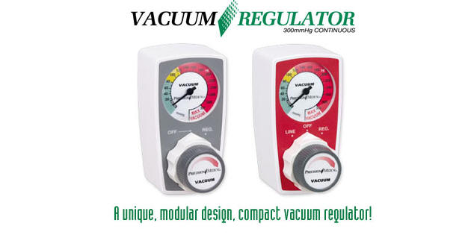

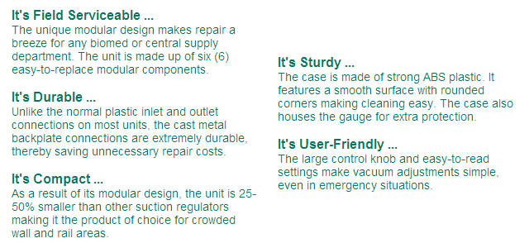

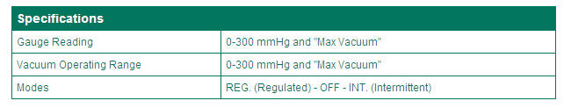

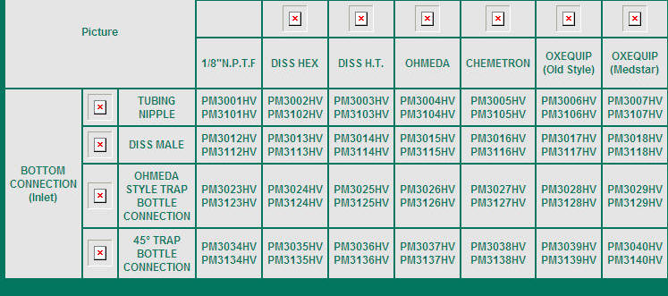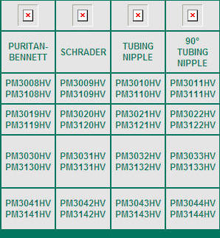

To place your order please contact Patrick McCarthy

Atmospheric Products and Services
17 Norris Run Court
Reisterstown, Maryland 21136
Office/Fax: 410-833-7170
Cell: 410-428-4454
Email: Patrick@apsusa.biz

