Model 475
LEVEL CONTROLLER with TEMPERATURE READOUT
FEATURES:
• Bright Control Function LED display
• Large alarm LED's for TEMP (temperature) REM (remote) XHIGH (high level alarm) XLOW (low level alarm)
• Single GREEN Normal LED indicating all systems are functioning properly.
• Bright YELLOW filling indicator
• Push to "START" and "STOP" buttons
• MUTE/ALARM SET/TEST button
• Manual "SPURT" button for defogging during a work mode.
• Auto DEFOG Set Adjustment
• Remote Output
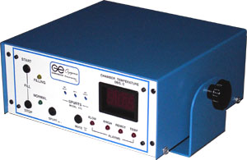
Model 475 Liquid Controller is a four (4) level controller, consisting of Low Level Alarm, Low Level Start Fill, High Level Stop Fill and High Level Alarm. An open lid temperature alarm has been added to alert the operator that the lid has been open for a dangerous duration of time.
The Model 475 is the most complete self contained monitoring system engineered. LED readouts indicate liquid nitrogen (LN2) level status; digital readouts provide continuous temperature information of the storage chamber and alerts technicians to unacceptable temperatures.
This sophisticated electronic alarm system is triggered when high temperature in the chamber is caused by an "Open Lid", and it also features a built-in Remote Relay output. This automatic fill system additionally includes a test circuit and alarm mute function, operating on 117V AC (Option 220V AC).

