Model 289
BY-PASS FOR PIPELINE SYSTEMS
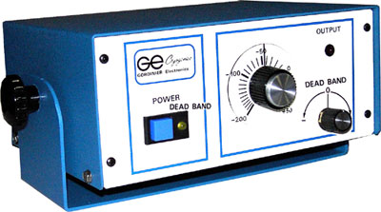
The Model 289 is a gas By-Pass temperature control system and is used when it is essential to by-pass gases from a feed line prior to the filling of storage units or the operation of other devices, such as microscopes. This nitrogen gas by-pass controller allows only liquid to enter the system used with individual LN2 supply tanks or pipeline branches.

